

**CAPSTONE PROJECT REPORT**

**Report 2 – Project Management Plan**

– Ho Chi Minh, July 2021 –

**Table of Contents**

I. Project Report 3

1. Status Report 3

2. Team Involvements 3

3. Issues/Suggestions 3

II. Project Management Plan 4

1. Overview 4

1.1 WBS & Estimation 4

1.2 Project Objectives 4

1.3 Project Risks 4

2. Management Approach 5

2.1 Project Process 5

2.2 Quality Management 5

2.3 Training Plan 5

3. Master Schedule 5

4. Project Organization 6

4.1 Team & Structures 6

4.2 Roles & Responsibilities 6

5. Project Communication 6

5.1 Communication Plan 6

5.2 External Interface 7

6. Configuration Management 7

6.1 Tools & Infrastructures 7

6.2 Document Management 8

6.3 Source Code Management 8

# Project Management Plan

## Overview

### WBS & Estimation

Reference to [Mumbi Sprint Backlog](https://docs.google.com/spreadsheets/d/1kCvDnlVReb_4tA43p_0lDAK5mRgLmtNHE3Vy76ylWkk/edit?usp=sharing)

### Project Objectives

* Timeliness: 70%
* Allocated Effort: 4 (members) * 12 (sprints) * 7 (days/sprint) = 336 man-days
* Estimated total cost:
* Quality:
* Be able to run in a real environment.
* Users can learn to use the system within 3-5 days.
* Saving time in reviewing and distributing subscriptions.

### Project Risks

| **#** | **Risk description** | **Impact** | **Possibility** | **Response plan** |
| --- | --- | --- | --- | --- |
| 1 | Members disagreed their own opinion with each other, leading to controversy | Because of conflicts and misunderstanding, progress is delayed. | Medium | Asking mentor to resolve it or vote |
| 2 | Lacking of technical knowledge on specific areas of the product | High | Low | Researching and getting advice from the supervisor |

*Table 4 - Project risks*

## Management Approach

### Project Process

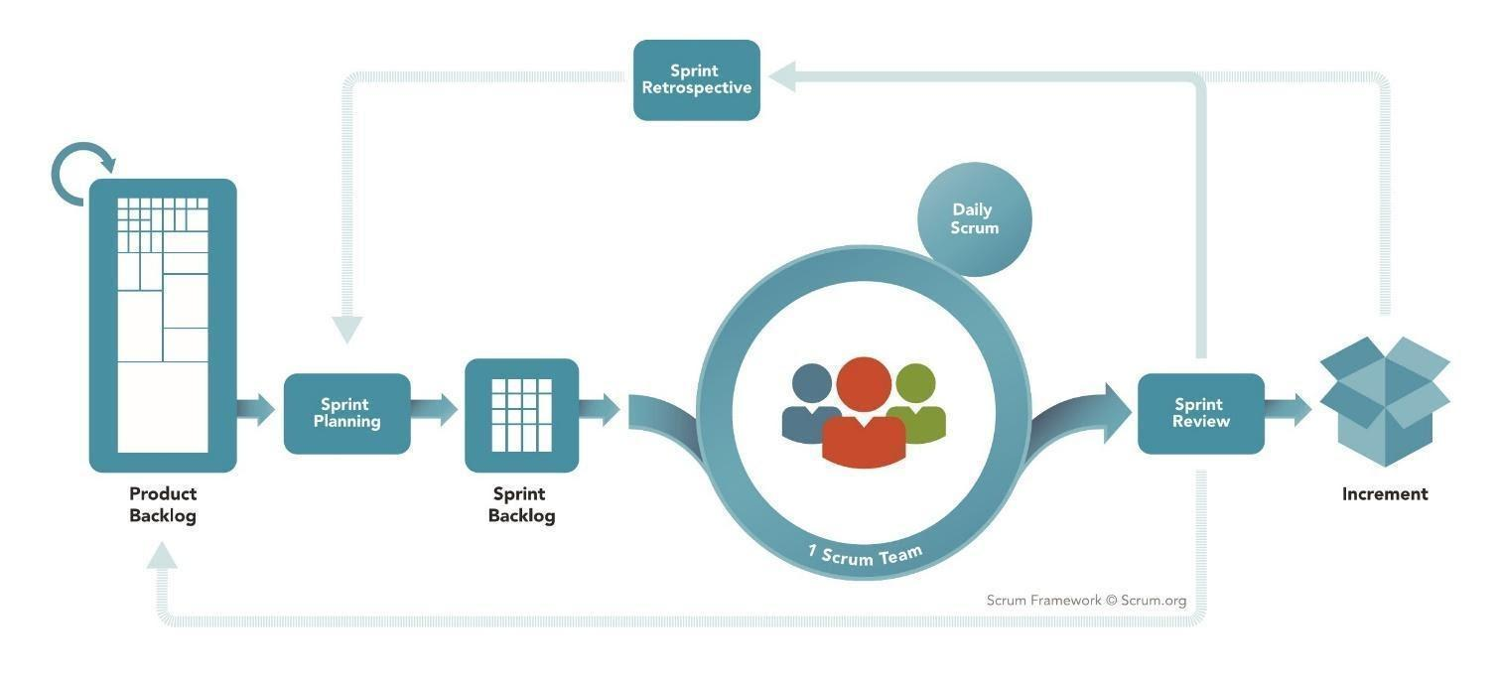

*Figure 1 - <Reference> Scrum Framework*

Reference: <https://www.scrum.org/resources/what-is-scrum>

Mumbi is developed using the Scrum model which is an agile framework for developing, delivering and maintaining products. Our team chooses this model for the following reasons:

* Scrum is designed for small and medium-sized projects, which is ideal for our four-person team.
* Each feature is assigned to two members, one is responsible for Front End, the other is in charge of Back End. This means that every person has to complete all the steps: designing, coding, implementing and testing, while still concentrating on their strengths. This allows us to work independently yet being able to collaborate and assist one another in every step of the process.
* For this project, each sprint spans 10 days and the duration of our product backlog is 11 sprints.

### Quality Management

To maximize the project quality, our team will apply the following tactics to improve the project quality:

* User acceptance tests as we develop more features.
* Cross-review each other’s code.

### Training Plan

| **Training Area** | **Participants** | **When, Duration** | **Waiver Criteria** |
| --- | --- | --- | --- |
| **C# & .Net core** | All team member | 20 man-days | Mandatory |
| **VueJs** | All team member | 20 man-days | Mandatory |
| **Firebase** | All team member | 4 man-days | Mandatory |
| **Git, Github** | All team member | 2 man-days | Mandatory |
| **Flutter** | All team member | 20 man-days | Mandatory |

*Table 5 - Training Plan*

## 3. Project Communication

### 3.1. Communication Plan

| **Communication Item** | **Who/target** | **Purpose** | **When, Frequency** | **Type,**  **Tool,**  **Method(s)** |
| --- | --- | --- | --- | --- |
| Computer | Team member | Internal communication | Always | Google meet |
| Phone | Supervisor | Upper Communication | Always | No |
| In-Person | Team members &  Supervisor | Get everyone on the same page | Daily 2 times/week | Face to face |
| In-Person | Team members & End-user | Confirm process | Weekly | Face to face |

*Table 6 - Communication Plan*

### 3.2. External Interface

| **Function** | **Contact Person (name, position)** | **Contact address (email, telephone)** | **Responsibility** |
| --- | --- | --- | --- |
| End-User | Vũ Thị Thùy Dương | duongvtt9@fe.edu.vn | - Provide document template  - Give instruction to project team  - Review deliverables  - Supervise project status  - Specify user requirement  - Control the development process  - Give out technique and business analysis support  - Analyze business rules  - Review the document and review project |
| End-User | More than 25 users |  | − Using and feedback. |

*Table 7 – External Interface*

## 4. Configuration Management

### 4.1. Tools & Infrastructures

| **Tools & Infrastructures** | **Names** |
| --- | --- |
| **Programming languages** | C#, Dart |
| **Framework** | VueJS 2.6, .Net Core 2.2, Entity Framework, Flutter |
| **DBMS** | SQL Server |
| **IDEs/Editors** | Visual Studio Code, IntelliJ |
| **UML tools** | StarUML, Draw.io |
| **Version Control** | Git |
| **Deployment server** | Amazon Web Service |
| **Project management tool** | Trello |

*Table 8 – Tools & Infrastructures*

### 4.2. Document Management

The project documents will be managed using Google Drive: <https://drive.google.com/drive/folders/1DjlNHjuP8RjWHeyc4Zfa_1qxY0G-tZZd?usp=sharing>

### 4.3. Source Code Management

The project source code will be managed: <https://drive.google.com/drive/folders/17q-h683r3qlisoBvCvjtLFABuv3x0kvw?usp=sharing>